**Python while Loop**

In Python, we use a while loop to repeat a block of code until a certain condition is met. For example,

number = 1

while number <= 3:

print(number)

number = number + 1

[Run Code](https://www.programiz.com/python-programming/online-compiler)

**Output**

1

2

3

In the above example, we have used a while loop to print the numbers from **1** to **3**. The loop runs as long as the condition number <= 3 is True.

**while Loop Syntax**

while condition:

# body of while loop

Here,

1. The while loop evaluates **condition**, which is a boolean expression.
2. If the condition is True, **body of while loop** is executed. The condition is evaluated again.
3. This process continues until the condition is False.
4. Once the condition evaluates to False, the loop terminates.

**Tip:** We should update the variables used in **condition** inside the loop so that it eventually evaluates to False. Otherwise, the loop keeps running, creating an infinite loop.

**Flowchart of Python while Loop**

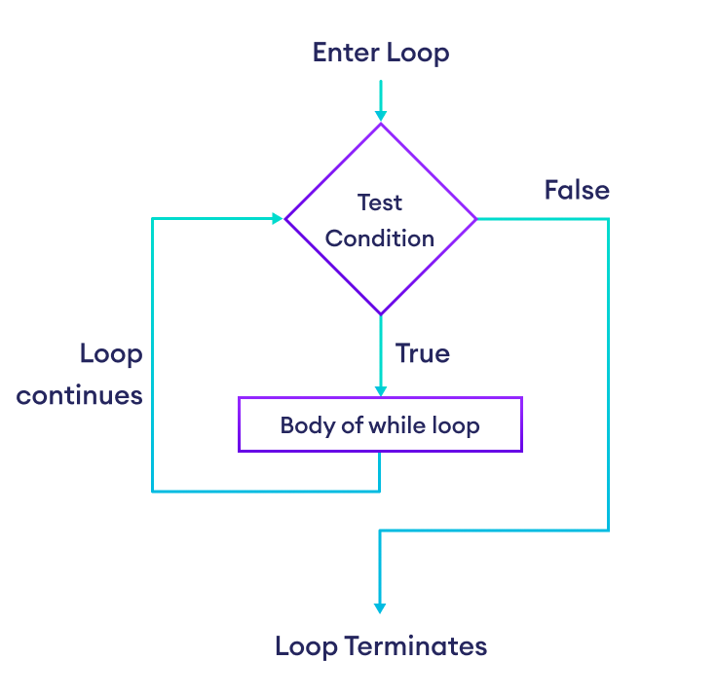Flowchart of Python while Loop

**Example: Python while Loop**

# Print numbers until the user enters 0

number = int(input('Enter a number: '))

# iterate until the user enters 0

while number != 0:

print(f'You entered {number}.')

number = int(input('Enter a number: '))

print('The end.')

[Run Code](https://www.programiz.com/python-programming/online-compiler)

**Output**

Enter a number: 3

You entered 3.

Enter a number: 1

You entered 1.

Enter a number: -4

You entered -4.

Enter a number: 0

The end.

Here is how the above program works:

1. It asks the user to enter a number.
2. If the user enters a number other than **0**, it is printed.
3. If the user enters **0**, the loop terminates.

**Infinite while Loop**

If the condition of a while loop always evaluates to True, the loop runs continuously, forming an **infinite while loop**. For example,

age = 32

# The test condition is always True

while age > 18:

print('You can vote')

[Run Code](https://www.programiz.com/python-programming/online-compiler)

**Output**

You can vote

You can vote

You can vote

.

.

.

The above program is equivalent to:

age = 32

# the test condition is always True

while True:

print('You can vote')

[Run Code](https://www.programiz.com/python-programming/online-compiler)

**More on Python while Loop**

Pythonwhileloop withbreakstatement

Pythonwhileloop with anelseclause

Python for loop vs while loop

**Also Read:**

* [Python if...else Statement](https://www.programiz.com/python-programming/if-elif-else)

Before we wrap up, let’s put your knowledge of Python while loop to the test! Can you solve the following challenge?

Challenge:

Write a function to get the Fibonacci sequence less than a given number.

* The Fibonacci sequence starts with **0** and **1**. Each subsequent number is the sum of the previous two.
* For input **22**, the return value should be [0, 1, 1, 2, 3, 5, 8, 13, 21]